October 10th, 2010
Hi,
As I began in the corresponding letter last year, not too much to write about this week.
For the second time in a week, my broadband connection broke! Actually both were not a complete break – the icon showed 'little or no connectivity'. This happened on Friday but on Saturday morning it seemed to have 'fixed' itself. However, I still allowed the technician to come in the afternoon to check things out but I don't think he really identified the cause of all these connection problems.
The weather is now, at times, a bit cooler and drier. And about time as we are nearly in November. At one time in the past, October used to be a very pleasant month, temperature-wise. The change means that there are fewer people using the swimming pool now and sometimes I have it to myself. Swam 7.5 km this past week.
The other day, I got an e-mail from the publishers in Singapore to adapt the Singapore Science books for use in Thailand. It should not be a major job though I asked if the English has to be simplified as the standard in Thailand is likely to be lower than it is in Singapore. But they are not expecting a major market there.
The same day I also got an e-mail from the Ivory Coast in West Africa. It was one of those get-rich scams that many people, especially in HK, seem to fall for. In this one, a lady was to inherit US$750 000 from her deceased father but needed me to be some kind of guarantor in order for the money to be released. In return I was to receive 15% of the sum. But the catch is I had to meet the person here first. Of course I never replied but will keep the e-mail as a souvenir. This particular e-mail came through an online Russian language school, which I have actually never used. The person writing to me made comments about my profile which is interesting as it is completely blank!!
The other day, an Israeli man on a Qantas plane flying to Melbourne from Australia threatened to bring down the plane by opening a door. He was overpowered by the crew and handcuffed to a seat. Planes must now carry handcuffs! The incident did not get much coverage here though.
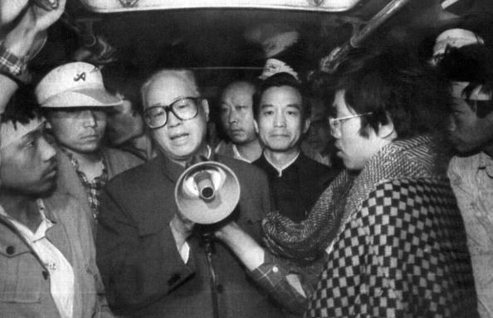
Then on Friday, as many people expected, the jailed Chinese intellectual and dissident Liu Xiaobo, received the Nobel peace prize to the fury of the Chinese government. I sent you an article on him some time ago. (I have attached it again for your reference.) The fact that it actually happened suggests that political changes are slowly occurring in China. And the prime minister Wen Jiabao is always making pronouncements about the need for political reform, the need for change in the Communist Party and to listen to what the people are saying. It is interesting that some of his comments are not actually published within China. I suspect that Wen Jaibao is a 'closet democratic'. There is a famous photo (shown below) of a former premier Zhao Ziyang (whose book I have commented on) in 1989 talking through a bullhorn to the students in Tiananmen Square; standing next to him is a younger Wen Jiabao (circled). I suspect that that incident had an affect on Wen but because of the system, he is unable to make dramatic changes. He is also a well-known fan of European culture and thought. It is also interesting that two books he most often reads are one by Adam Smith and another by a 'good' Roman emperor Marcus Aurelius, both of which deal with the importance of morality in commerce and public life. It is possible that China could change suddenly just as happened in Taiwan. The KMT, which escaped to Taiwan following the 1949 Communist victory in China, set up a repressive one-party state just as China is today. But there were gradual changes and then a sudden collapse of the system to be replaced by the present democratic system and related freedoms.
I mentioned earlier about the Rugby test between NZ and Australia which is to be held soon in HK. Ticket sales have picked up a little and still only about half have been sold. To try to bolster sales, the local Rugby union is to have a 'meet the fans' session for a couple of hours for ticket-holders to meet the players.
The CE is to give his annual policy address this coming Wednesday. He has been told from a wide of sources to do more to help the increasing number of 'poor' (now standing about 18% of the population, according to the definition used, and rising fast) with more than just a few handouts, and to do something about the property 'bubble' which is preventing many from being able to afford a home. And, would you believe it, the extremely greedy developers, responsible for a lot of the property problems, have asked the CE to reduce commercial taxes from an already low 16.5% to 15%!!
That’s about it for now.
Cheers

